**Capstone Project Phase A**

**ProConnect**

**Project Code: 23-2-D-9**

**Instructor:**

**Ronen Zilber**

**Team:**

| **Abd Elaziz Hamed** | **azizhamed20@gmail.com** |
| --- | --- |
| **Hadi Danial** | **hadidanial97@gmail.com** |



# Table of Contents

**Table of Contents 1**

**Abstract 2**

**1. Introduction 2**

**2. Related Work 6**

**3. Expected Achievements 8**

Project Goals 8

Functionality 9

User Adoption 9

Improve Efficiency 9

Enhanced User Experience 10

Business Impact 10

Scalability and Future Growth 10

Impact on the Construction Industry 11

**4. Research / Engineering Process 12**

**4.1. Process 12**

Research – The problem in the construction industry 12

Determining Technologies 12

Constraints and challenges 15

**4.2. Product 16**

4.2.1. Requirements 16

Functional: 16

Non-Functional: 18

4.2.2 Mockups 19

**5. Verification and Evaluation 22**

5.1. Evaluation 22

5.2. Verification 24

**6. Diagrams 26**

6.1 Architecture 26

6.2 Class 26

6.3 Use Case 28

6.4 Activity 29

**7. References 31**

# Abstract

Our project is a mobile/web application designed to connect homeowners with skilled workers in the construction industry, such as painters, carpenters, and tilers. The app enables homeowners to search for and hire workers for their construction needs based on their skills, experience, and location. At the same time, skilled workers can use the app to search for job opportunities, apply for jobs, and receive notifications when suitable jobs become available. The app also includes a review and rating system that allows homeowners to rate the quality of work provided by workers, ensuring a high standard of service. By leveraging advanced technologies such as geolocation services, job search engines, and data analysis, our app aims to streamline the process of finding and hiring construction workers, saving homeowners time and money, while also helping skilled workers find job opportunities easily.

# 1. Introduction

The construction industry is one of the largest industries in the world and is responsible for building homes, offices, factories, and other buildings that we all rely on. However, the process of finding suitable workers for construction projects can be challenging for both homeowners and workers. Workers may struggle to find jobs that match their skills and experience, while homeowners may struggle to find workers who are reliable and have the necessary expertise to complete their project.

Our application/ website aims to revolutionize the way homeowners and construction workers connect with each other. The platform is designed to streamline the process of finding and hiring skilled workers for construction projects, and to help workers find job opportunities that match their skills and preferences. The app includes a comprehensive job search engine that allows workers to search for job openings by location, job type, and other criteria. Workers can also create profiles highlighting their skills and experience, and can apply to job openings directly through the platform.

For homeowners, the app provides an easy-to-use interface for finding and hiring skilled workers for their projects. Homeowners can search for workers by job type, location, and other criteria, and can view worker profiles and reviews before making a hiring decision.

To ensure that the platform remains up-to-date and relevant, we will conduct ongoing research into the construction industry and related fields. This research will involve analyzing data related to job postings, salaries, job growth projections, and other relevant factors, and using this information to inform the development of the platform. Additionally, we will use data analysis to track and measure the success of the platform, such as user engagement and job placements.

Overall, our application provides a simple, user-friendly solution for connecting homeowners and construction workers, and aims to create a more efficient, effective, and profitable construction industry.

The website will be developed using React Native, a powerful and popular framework for building mobile applications. React Native allows for the development of cross-platform applications, meaning that the codebase can be shared across multiple platforms, such as iOS and Android, reducing development time and effort. With its extensive library of pre-built components and intuitive syntax, React Native enables the creation of highly interactive and visually appealing user interfaces.

For the database, MySQL will be utilized as the chosen database management system. MySQL is a reliable and widely-used relational database that offers robust data storage and retrieval capabilities. It provides support for structured query language (SQL), allowing efficient querying and manipulation of data. MySQL's scalability and performance make it suitable for handling large volumes of data in a secure and efficient manner.

In comparison to MongoDB, which is a popular document-oriented NoSQL database, MySQL follows a relational data model. This means that MySQL organizes data into tables with predefined schemas, allowing for strict data integrity and enforcing relationships between tables using foreign keys. On the other hand, MongoDB adopts a document-oriented approach, where data is stored in flexible, JSON-like documents without predefined schemas. This provides more flexibility in handling evolving data structures and accommodating changes without affecting existing data.

Additionally, MySQL offers ACID compliance, ensuring the atomicity, consistency, isolation, and durability of transactions. It is well-suited for applications that require complex joins, strict data integrity, and support for SQL querying. MongoDB, on the other hand, excels in handling rapidly changing and unstructured data, providing horizontal scalability and high performance. It allows for flexible data modeling and is commonly used in modern web and mobile applications.

To ensure the security of transactions, RSA encryption will be employed. RSA (Rivest-Shamir-Adleman) is an asymmetric encryption algorithm widely used for secure data transmission and storage. It utilizes a pair of keys, a public key for encryption and a private key for decryption. By encrypting sensitive data using the public key and decrypting it with the private key, RSA encryption ensures that data transmitted between the client and server remains confidential and tamper-proof.

When comparing RSA to DES and AES, the primary distinction is in their encryption techniques and use cases. RSA is an asymmetric encryption algorithm that excels in key exchange and digital signatures, while DES and AES are symmetric encryption algorithms that focus on bulk data encryption. RSA provides secure key exchange and authentication without the need for a shared secret, but it is slower and more computationally intensive compared to DES and AES.

DES, although historically significant, is considered relatively weak due to its small key size. AES, on the other hand, offers stronger security and better performance. AES has become the de facto standard for symmetric encryption and is widely adopted in various industries.

In summary, RSA is used for key exchange and digital signatures, while DES and AES are symmetric encryption algorithms used for bulk data encryption. RSA offers robust security but is slower and more computationally intensive, while AES provides strong security and better performance. DES, although once widely used, is now considered relatively weak compared to modern encryption standards. The choice of encryption algorithm depends on the specific requirements of the application, such as security, performance, and compatibility.

Additionally, the mobile application will be developed using React Native, leveraging its flexibility and performance. React Native's modular architecture allows for efficient development, code reuse, and easy maintenance. The application will establish a connection to the server using appropriate network protocols, such as HTTPS or WebSocket, enabling seamless communication between the client and the server for data synchronization and real-time updates. This connection will facilitate the exchange of information, enabling users to interact with the application and access the required data stored on the server.

# 2. Related Work

In comparison to existing applications like Angie's List, Thumbtack and pro.co.il that specialize in connecting professionals, our application/website offers a comprehensive platform that revolutionizes the way workers, professionals, homeowners, and contractors interact within the construction industry. One of the key differentiators of our platform is its ability to connect beginner workers with experienced professionals. By facilitating these connections and fostering relationships, our application/website creates an environment where beginners can learn from professionals, gain valuable insights, and enhance their skills. This unique feature sets our platform apart by providing a supportive and collaborative community where knowledge transfer and professional growth are prioritized.

Furthermore, our application/website serves as a bridge between professionals and homeowners, catering to the needs of both parties. Homeowners can easily search for professionals based on their specific requirements and preferences, ensuring that they find the right fit for their construction projects. Simultaneously, professionals gain access to a broader pool of potential clients, expanding their opportunities for project acquisition and business growth. This two-way connection fosters mutually beneficial relationships and streamlines the process of finding suitable professionals or projects.

Another distinctive aspect of our application/website is its focus on facilitating seamless communication and collaboration between homeowners or clients and contractors. We recognize the significance of the contractor-client relationship in successful project management. Therefore, our platform offers features that enable clients to authorize contractors to manage the building process. This integration empowers contractors with the necessary tools to efficiently oversee projects, leveraging their expertise to ensure timely and quality completion. Through our application/website, clients can easily connect with contractors, facilitating effective communication, and promoting transparency throughout the construction journey.

Moreover, our application/website understands the crucial link between contractors and professionals. We provide a dedicated space where contractors can connect with skilled professionals, simplifying the process of finding the right workers for specific projects. This feature enhances efficiency by enabling contractors to assemble a team of professionals with the required expertise, thereby streamlining project execution and ensuring optimal results.

In summary, our application/website goes beyond the conventional model of connecting professionals by creating a comprehensive ecosystem that benefits workers, professionals, homeowners, and contractors. With a focus on knowledge-sharing, seamless connections, efficient project management, and enhanced collaboration, our platform offers a transformative solution that drives productivity, fosters growth, and improves overall outcomes in the construction industry.

# 

# 3. Expected Achievements

## Project Goals

Our project encompasses a comprehensive set of goals that aim to transform the way homeowners, professionals, contractors, and workers interact within the construction industry. Firstly, we aim to create a robust application/website that connects homeowners with professionals, facilitating seamless communication and efficient project collaboration. By providing a centralized platform, we eliminate the need for homeowners to manually search for professionals and streamline the process of finding the right match for their specific needs.

Secondly, our application/website bridges the gap between homeowners and contractors, enabling a smooth workflow and effective project management. Homeowners can easily connect with contractors, allowing them to delegate project management responsibilities to experienced professionals who possess the necessary expertise. This ensures that projects are executed efficiently and in accordance with the homeowner's requirements.

Another goal is introducing our application to real workers and clients to gather authentic feedback and reviews. We understand the importance of real-world user experiences in shaping the development and improvement of our application. By engaging with actual workers and clients, we aim to obtain valuable insights into the usability, functionality, and overall satisfaction with our platform.

By actively seeking reviews and feedback from users, we can identify areas of strength and areas that require further enhancement. Real reviews provide us with firsthand information about the effectiveness of our application in meeting the needs of workers and clients in the construction industry. We value the input of our users as it helps us refine and optimize our platform to better serve their requirements.

## Functionality

Furthermore, our platform facilitates connections between professionals and contractors, empowering professionals to expand their network and gain access to a wider range of job opportunities. By fostering collaboration between these two vital entities, our application/website strengthens the construction ecosystem, encouraging seamless cooperation and knowledge sharing.

Additionally, we provide a channel for professionals to connect with workers, allowing them to find and onboard the skilled workforce required for their projects. This feature simplifies the process of identifying and hiring workers, minimizing recruitment challenges and ensuring the availability of the right talent at the right time.

Our application/website aims to enhance the job flow by offering a range of features that simplify project management. Users can utilize tools for job posting, search filters, review systems, and real-time updates, streamlining communication and eliminating the need for manual coordination. This enhanced functionality improves overall efficiency and project outcomes.

## User Adoption

In terms of user adoption, we prioritize user-centered design principles to ensure an intuitive and engaging experience. Through clear instructions, intuitive navigation, and robust support features, we aim to create a platform that users find easy to navigate and utilize effectively. By providing a seamless and enjoyable experience, we aim to encourage widespread adoption and engagement with our application/website.

## Improve Efficiency

The improved efficiency brought about by our application/website extends beyond project management to resource allocation. By connecting homeowners, professionals, contractors, and workers through a centralized platform, we optimize the utilization of resources, reducing wastage and maximizing cost-effectiveness. This optimization contributes to increased profitability for professionals and contractors, while providing homeowners with cost-efficient and timely project outcomes.

## Enhanced User Experience

Moreover, our application/website focuses on enhancing the user experience by personalizing recommendations and facilitating seamless communication channels. Users can benefit from tailored suggestions and customized search results, ensuring that they find the most suitable professionals, contractors, and workers for their specific needs. Real-time communication capabilities enable swift and effective decision-making, promoting a collaborative environment and fostering positive interactions between all stakeholders.

## Business Impact

From a business perspective, our application/website has the potential to make a significant impact on the construction industry. By providing a centralized platform that connects homeowners, professionals, contractors, and workers, we create an ecosystem that fosters collaboration, innovation, and growth. This can lead to increased job opportunities, business expansion, and improved profitability for professionals, contractors, and workers.

## Scalability and Future Growth

Furthermore, the scalability and future growth of our application/website are essential considerations. We will ensure that our platform is built on a robust and scalable architecture, capable of accommodating growing user demands. We plan to regularly update and enhance our application/website based on user feedback and industry trends, which will allow us to continuously evolve and provide an up-to-date and relevant solution for the construction industry.

## Impact on the Construction Industry

In conclusion, our project aims to transform the construction industry by connecting homeowners, professionals, contractors, and workers through a comprehensive and user-friendly application/website. By streamlining communication, optimizing resource allocation, and fostering collaboration, we facilitate efficient project management, enhance the user experience, and drive positive business impact. Through scalability, innovation, and a focus on user needs, we aspire to make a lasting impact on the construction industry and contribute to its continued growth and development.

# 4. Research / Engineering Process

The information gathering and learning process has been a crucial aspect that has influenced various aspects of the development. Thus far, our focus has been on two main areas: acquiring theoretical knowledge and understanding the practical considerations of integrating different technologies into our application.

## 4.1. Process

### Research – The problem in the construction industry

The research and engineering development process for our project began with a comprehensive understanding of the challenges faced in the construction industry. We recognized that there was a significant problem in managing work effectively, where homeowners and contractors struggled to find professionals easily, professionals faced difficulties in finding suitable work opportunities, and beginner workers encountered challenges in connecting with professionals for employment. To address these multifaceted issues, we embarked on developing an application/website that would provide a comprehensive solution.

### Determining Technologies

In determining the technologies for our application/website, we carefully considered the specific requirements of our project. For the front-end programming framework, we selected React Native, a powerful and popular cross-platform framework. React Native offers a rich ecosystem of pre-built components and extensive community support, ensuring a smooth and consistent user experience across different platforms. For the back-end, we have decided to leverage the Spring Boot framework. Spring Boot provides a comprehensive set of tools and libraries that simplify the development of robust and scalable web applications. It offers features such as dependency injection, integrated testing support, and seamless integration with various data storage solutions.

Additionally, we chose to adopt the Model-View-Controller (MVC) architectural pattern for our application/website.

The MVC pattern provides a structured approach to organizing our codebase, separating concerns and promoting maintainability. The Model represents the data and business logic of our application, ensuring proper data management and manipulation. The View handles the user interface components, ensuring a visually appealing and intuitive design. Finally, the Controller acts as an intermediary between the Model and the View, handling user input and facilitating the flow of information between the two.

By adopting the MVC pattern, we aim to achieve code modularity, reusability, and scalability. It allows for easier collaboration among team members, as different parts of the application can be developed independently. Furthermore, the separation of concerns enables us to make changes or add new features without impacting other components, reducing the risk of introducing bugs and simplifying maintenance.

Regarding data security, we made the decision to incorporate RSA encryption into our application/website. RSA encryption is a widely used asymmetric encryption algorithm known for its strong security features. By employing RSA encryption, we can ensure that sensitive user information, such as login credentials and personal data, is securely transmitted and stored in our system. This encryption technique utilizes a public-private key pair, where data encrypted with the public key can only be decrypted with the corresponding private key, providing an additional layer of protection against unauthorized access.

By carefully selecting React Native as our programming framework and adopting the MVC architectural pattern, we aim to develop a robust and maintainable application/website. Additionally, incorporating RSA encryption enhances the security of our system, instilling trust and confidence among our users. These technology choices align with our goal of providing a seamless and secure platform that connects professionals, homeowners, contractors, and beginner workers, facilitating efficient collaboration and improving the overall job flow in the construction industry.

By utilizing Spring Boot, we can streamline the development process, accelerate time-to-market, and ensure the reliability and performance of our application/website. The framework's convention-over-configuration approach reduces the need for manual configuration, allowing us to focus more on implementing the core functionalities of our system. Furthermore, Spring Boot's built-in security features and support for RESTful APIs align with our goal of ensuring the privacy and integrity of user data during communication and storage.

Throughout the development process, we anticipate challenges related to integrating the various components of our application/website seamlessly. This includes establishing smooth communication between the frontend and backend, ensuring data consistency and synchronization. To address these challenges, we will conduct rigorous testing to identify and resolve any issues that may arise.

During the development process, we encountered challenges in determining the most effective algorithms to match professionals with homeowners' specific requirements and preferences. We conducted extensive research to explore various matching algorithms and considered factors such as skills, location, availability, and ratings/reviews. Additionally, we faced the task of defining the system's requirements and features, carefully considering what the system should offer to ensure an optimal user experience. This involved refining the user interface, designing intuitive navigation, and implementing real-time communication features to facilitate seamless collaboration between stakeholders.

### 

### Constraints and challenges

Looking ahead, we anticipate potential challenges and obstacles that may arise during the project's lifecycle. As we venture into the realm of React Native and build an application/website, we acknowledge that there will be a learning curve and potential difficulties in mastering the frameworks and effectively translating our design into a functional and user-friendly interface. However, we are committed to investing the necessary time and resources in learning and staying updated with the latest technologies, frameworks, and best practices to overcome these challenges successfully.

By recognizing and addressing these challenges throughout the research and engineering process, we aim to deliver a high-quality application/website that revolutionizes the way professionals, homeowners, contractors, and beginner workers connect and collaborate in the construction industry. Our continuous learning, adaptability, and problem-solving mindset will play pivotal roles in developing a robust and innovative solution that meets the needs and expectations of all stakeholders involved.

## 4.2. Product

### 4.2.1. Requirements

#### Functional:

| 1 | The system allows the homeowners or the contractors to send professional Job offers. |
| --- | --- |
| 2 | The system allows the professional to accept or reject job offers. |
| 3 | The system allows homeowners to post jobs. |
| 4 | The system allows homeowners to send job offers to contractors. |
| 5 | The system allows the contractors to accept or reject job offers. |
| 6 | The system allows the homeowners or the contractors to manage their budget. |
| 7 | The system allows the contractors to view the table of the professionals that they work with. |
| 8 | The system allows the contractors to terminate professionals. |
| 9 | The system allows the contractors to view job applicants from professional |
| 10 | The system allows the contractors to accept or reject job applicants. |
| 11 | The system allows the professionals to send job applicants to contractors. |
| 12 | The system allows professionals to send job offers to homeowners and view posts that are posted by them. |
| 13 | The system allows professionals to view job applicants by workers. |
| 14. | The system allows professionals to accept or reject job applicants by workers. |
| 15. | The system allows professionals to view their workers table. |
| 16. | The system allows professionals to terminate workers. |
| 17. | The system allows professionals to view their job applicants to contractors. |
| 18. | The system allows the professionals and the workers to track their work hours. |
| 19. | The system allows professionals to post jobs. |
| 20. | The system allows workers to send professionals job applicants. |
| 21. | The system allows workers to apply for specific jobs for professionals. |
| 22. | The system allows workers to view the professionals that they work with. |
| 23. | The system allows workers to view and manage their job applicants. |
| 24. | The system allows workers to send professionals that they stopped to work with him. |
| 25. | The system allows chatting. |

#### Non-Functional:

| 1. | The application should work on both mobile and desktop devices. |
| --- | --- |
| 2. | The application should be user friendly and easy to use, even for people without any technical experience. |
| 3. | The application should be fast and responsive, both the user interface and the server response times. |
| 4. | The application should be able to accurately and quickly save and load user data. |
| 5. | The application should be able to handle large amounts of traffic/users at the same time. |
| 6. | The application should be secure and encrypt data to protect the users. |

### 4.2.2 Mockups

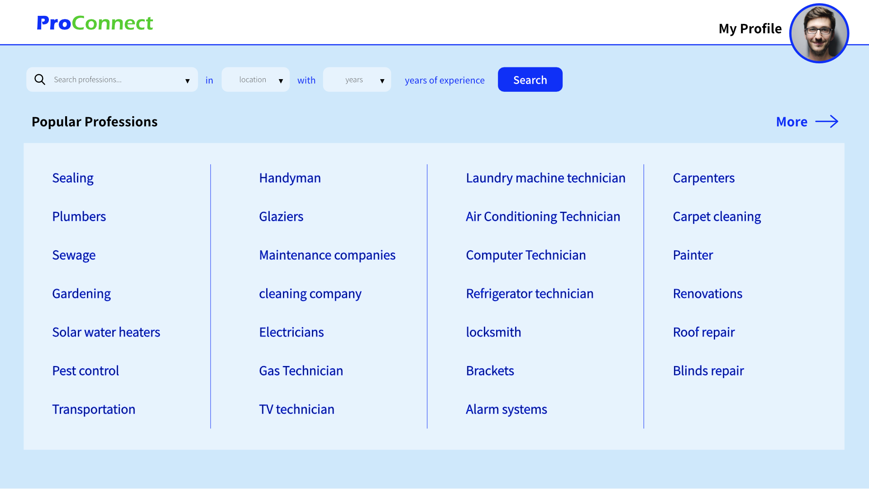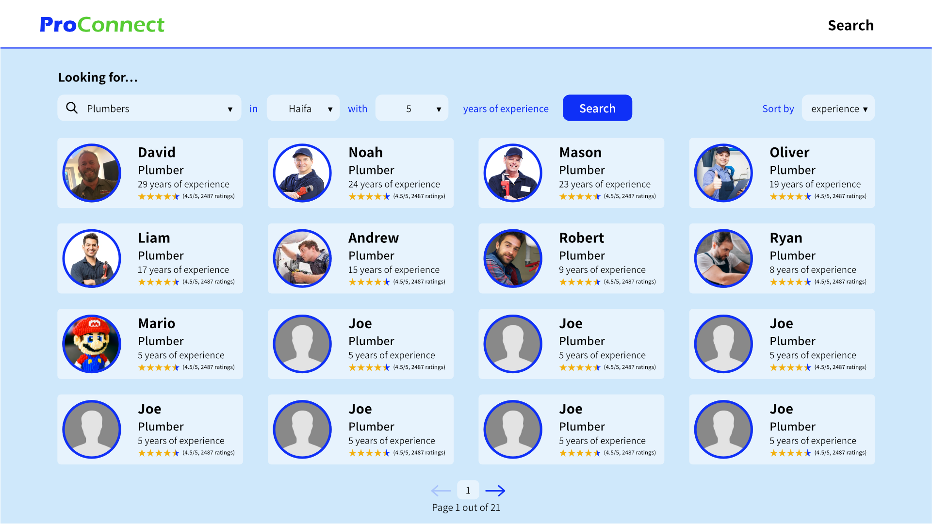

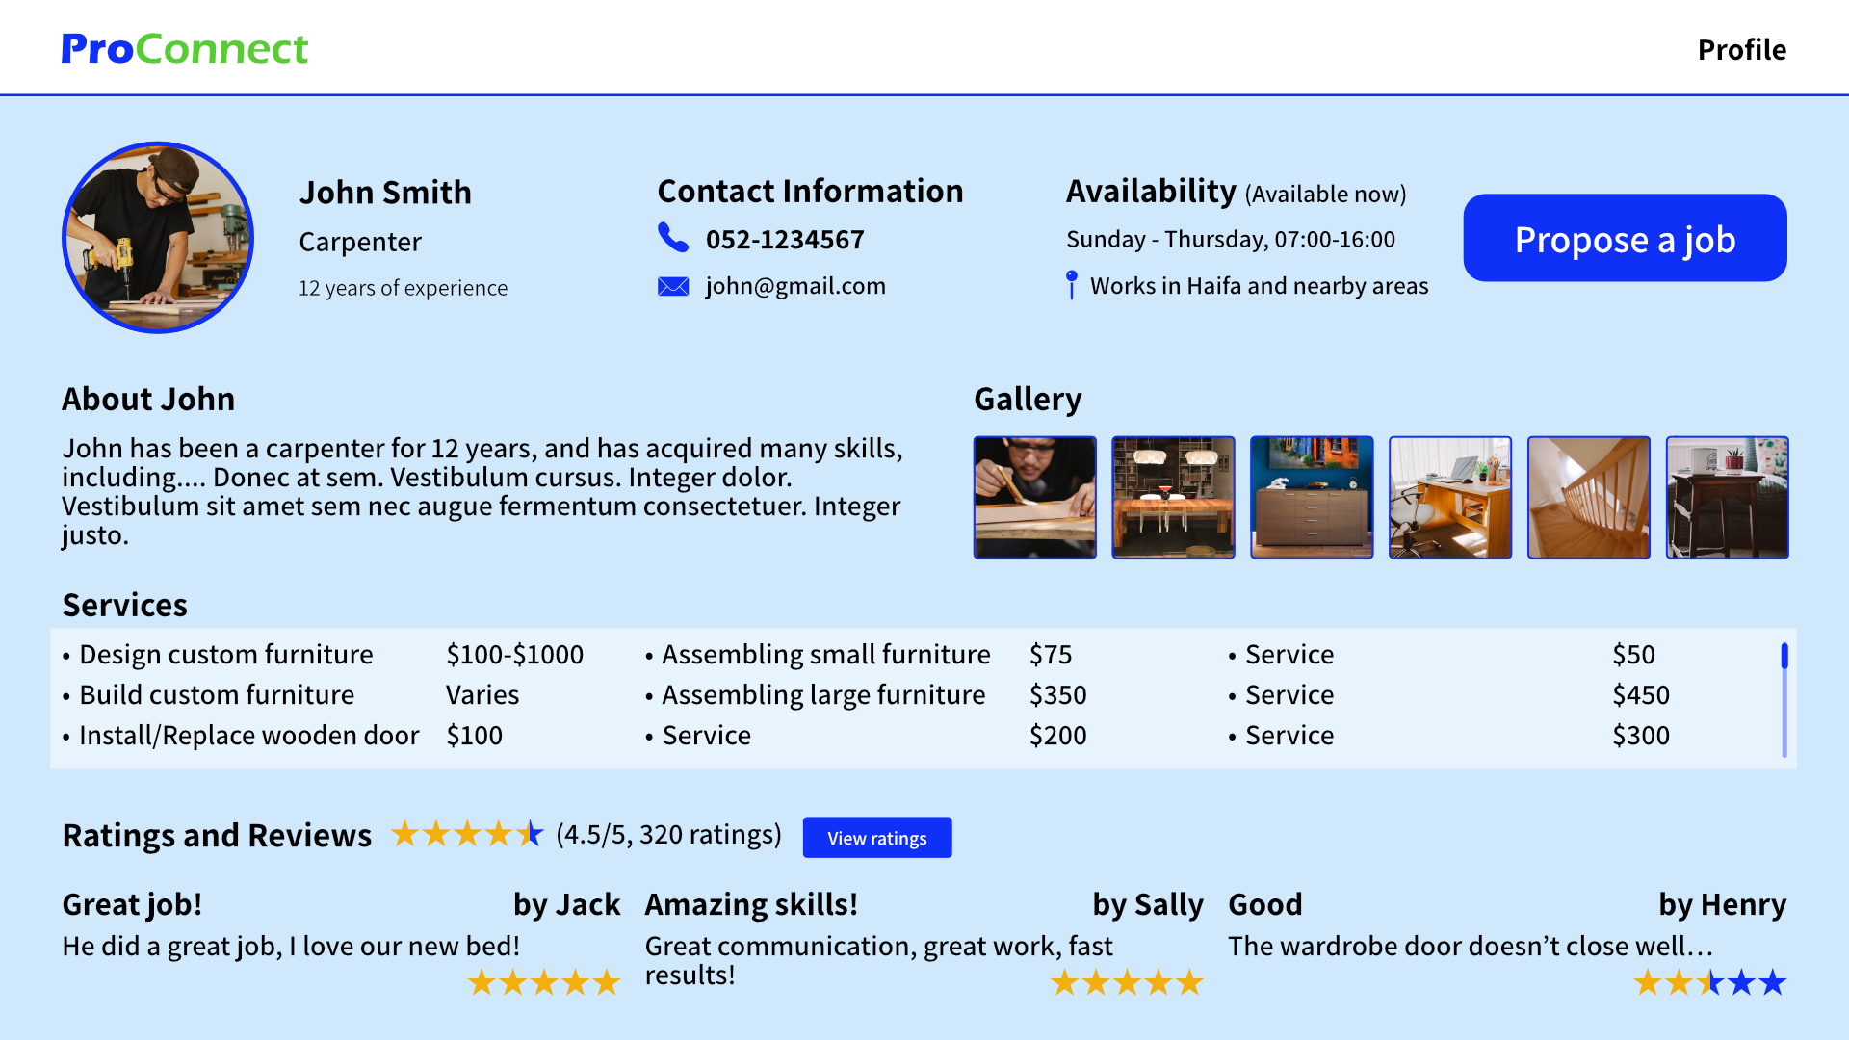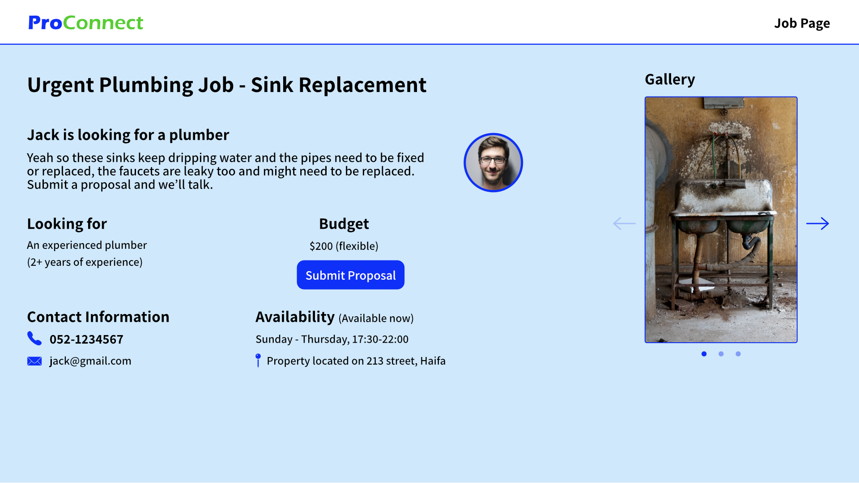

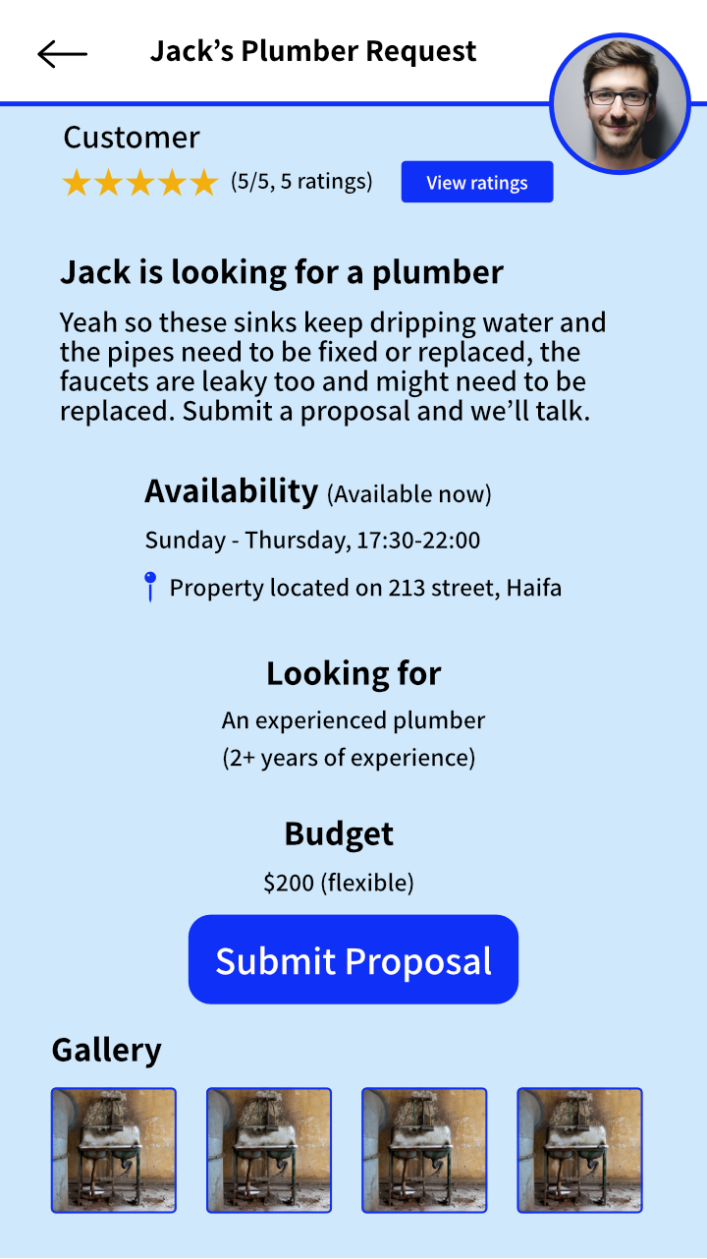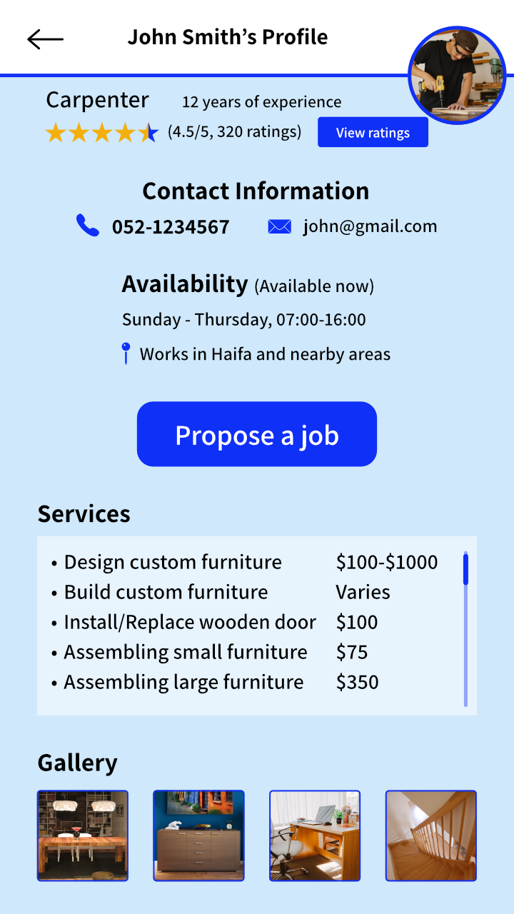

# 5. Verification and Evaluation

## 5.1. Evaluation

To ensure the success and effectiveness of our project, we have planned a comprehensive evaluation process that includes user testing, performance metrics analysis, comparative analysis, and a business impact assessment.

Firstly, we will conduct extensive user testing sessions to gather feedback and insights from various stakeholders, including homeowners, contractors, professionals, and workers. By observing their interactions with the system, we can evaluate the usability, functionality, and overall user experience. Their feedback will be invaluable in identifying any pain points, areas for improvement, and features that resonate well with them. This user-centric approach will help us refine the application/website and ensure it meets the needs and expectations of our target users.

Secondly, we will monitor and analyze performance metrics specific to our application. This includes measuring response times, loading speed, and server uptime to ensure optimal performance and user satisfaction. By setting up monitoring tools, we can promptly identify and address any performance issues that may arise. Additionally, we will track user engagement metrics, such as active usage, session durations, and conversion rates, to assess the application's effectiveness in capturing and retaining user interest.

Furthermore, we will conduct a comparative analysis of our application/website with similar existing platforms in the market. This analysis will help us benchmark our project, identify areas of differentiation, and evaluate its competitive advantages. We will assess factors such as functionality, user experience, unique features, and overall value proposition. By understanding our strengths and weaknesses in relation to competitors, we can strategically position our project and continuously improve its offering to stand out in the market.

Lastly, we will conduct a comprehensive business impact assessment to gauge the success and potential growth of our project. This assessment will involve analyzing key metrics such as user acquisition, user retention rates, revenue generation, and market penetration. By examining the project's impact on the construction industry, including cost savings, time efficiencies, and enhanced workflow management, we can demonstrate its value proposition and potential for long-term success.

Through these evaluation methods, we aim to gather valuable insights, identify areas for enhancement, and make data-driven decisions to optimize the performance, user satisfaction, and business impact of our application/website. The iterative nature of our evaluation process will ensure continuous improvement and align our project with the evolving needs of the construction industry and its stakeholders.

## 5.2. Verification

| Test | Tested Function | Expected Result |
| --- | --- | --- |
| 1 | User registration with correct parameters. | Successfully user registration and the new user inserted to the database. |
| 2 | User registration with non-correct parameters. | Unsuccessful user registration and the new user did not insert into the database. |
| 3 | User login with correct username and password. | Successfully user login |
| 4 | User login with incorrect username and password. | Unsuccessful user login. |
| 5 | Homeowner Searches for professionals with filtering. | Homeowner received results that are suitable for the filtering. |
| 6 | Homeowners send job offers to professionals. | Homeowner can see his job offer on the table and the professional received that job offer. |
| 7 | Homeowners post jobs. | Professionals with job preferences suitable to the post can see the post. |
| 8 | Homeowners accept job offers from professionals. | Professional inserted into the table. |
| 9 | Chat Test. | The message has to arrive correctly and to the right person. |
| 10 | Homeowner searches for contractors with filtering. | Homeowner received results that are suitable for the filtering. |
| 11 | Homeowner sends job offers to contractors. | Homeowner can see his job offer on the table and the contractor received that job offer. |
| 12 | Professionals apply to work with contractors. | Contractor can see the employment request. |
| 13 | Professionals accept job applicants from workers. | Worker inserted into professional’s workers table and the professional inserted into worker’s professionals table. |
| 14 | Professional rejects job applicant from worker. | Worker was not inserted into the professional's workers table. |
| 15 | Workers search for professionals. | Workers received results that are suitable for the filtering |
| 16 | Worker applies to work with a professional. | The request was sent to a professional and Inserted into his requests table. |
| 17 | Contractor accepts job applyment from professionals. | Professional inserted into his professionals table, and Contractor inserted into professional’s contractors table. |
| 18 | Contractor accepts a job offer from the homeowner. | Homeowner inserted into the table of homeowners. |

# 6. Diagrams

## 6.1 Architecture

## 6.2 Class

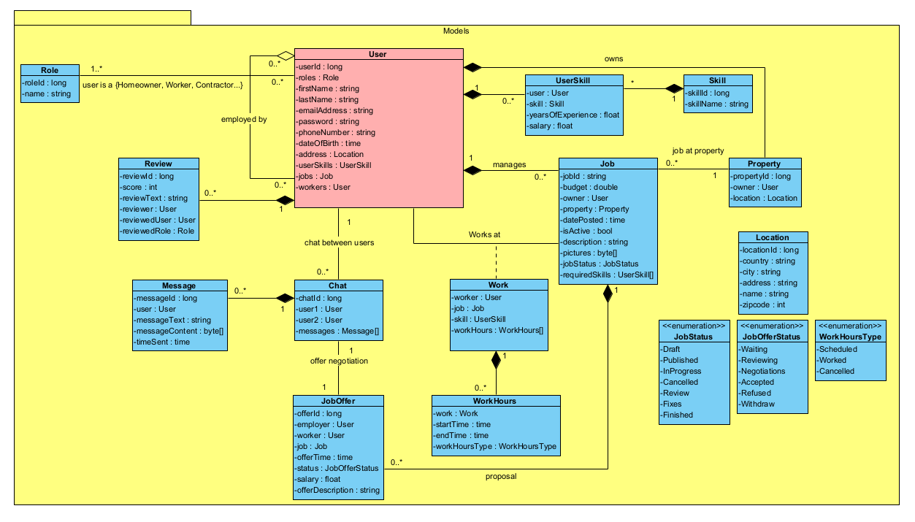

Building a class diagram helped us decide on what entities we need for our system and how they interact, which in turn will help us decide on how to design the architecture of the project and our databases.

## 6.3 Use Case

## 

In order to better understand and define the features of ProConnect, we build a Use Case diagram that displays most of the interactions that users can have with the system. This will be useful when deciding on what features to add and to avoid scope creep.

## 6.4 Activity

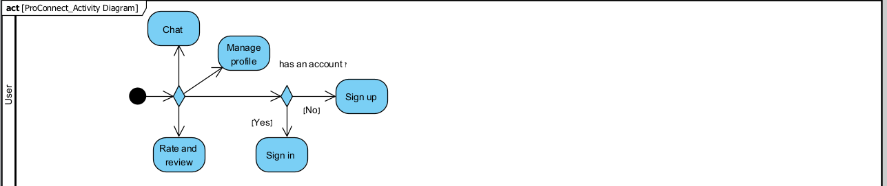

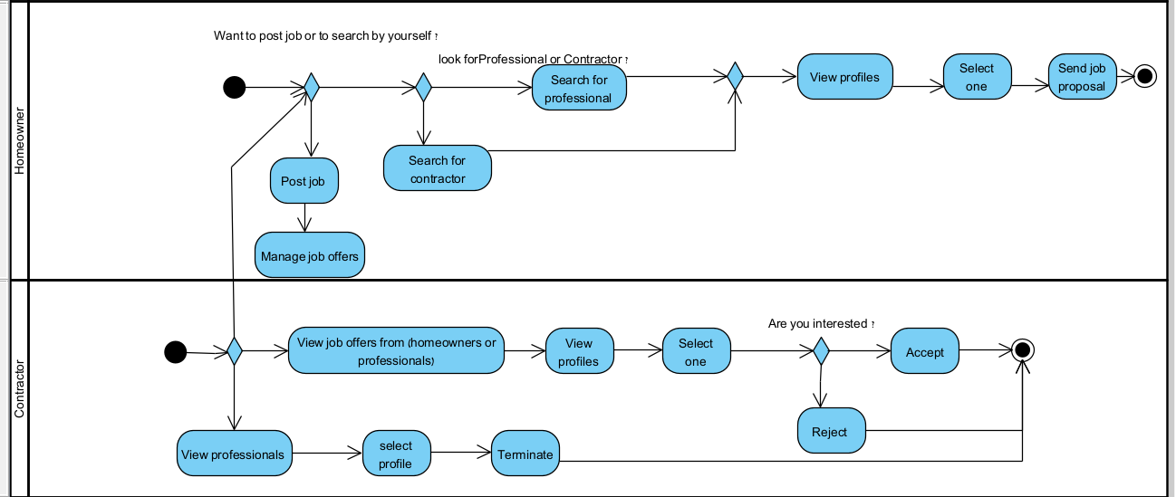

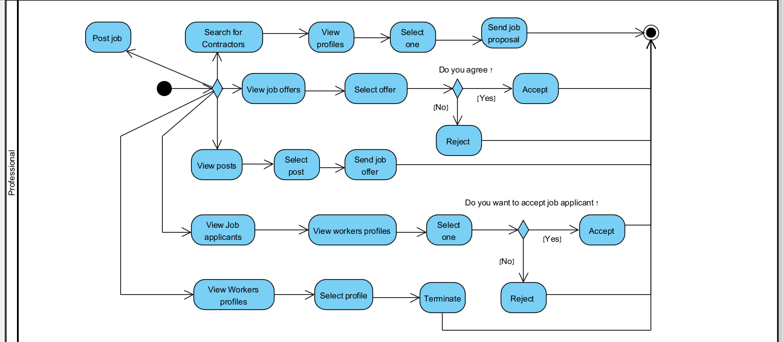

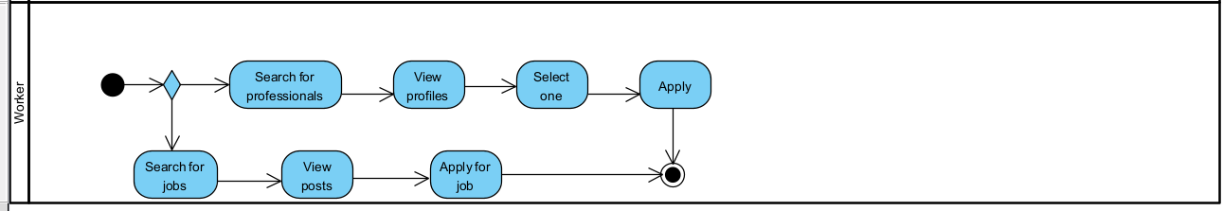

The activity diagram helped us understand the flow of the system and how one action leads to the next.

# **7.** **References**

## Similar Sites

[**המקצוענים • בעלי מקצוע מומלצים (pro.co.il)**](https://www.pro.co.il/)

[**Thumbtack | Care for Your Home | Find Local Pros & Reviews**](https://www.thumbtack.com/)

[**Angi (formerly Angie's List): Home Service Pros & Reviews**](https://www.angi.com/)

## Resources

[**What Is MySQL? | Oracle**](https://www.oracle.com/mysql/what-is-mysql/)

[**What is RSA encryption and how does it work? (comparitech.com)**](https://www.comparitech.com/blog/information-security/rsa-encryption/)

[**Data Encryption Standard (DES) | Britannica**](https://www.britannica.com/topic/Data-Encryption-Standard)

[**AES Encryption | Everything you need to know about AES (proprivacy.com)**](https://proprivacy.com/guides/aes-encryption)

[**React Native · Learn once, write anywhere**](https://reactnative.dev/)

[**Getting Started | Building an Application with Spring Boot**](https://spring.io/guides/gs/spring-boot/)

[**Spring Data JPA**](https://docs.spring.io/spring-data/jpa/docs/current/reference/html/#reference)

[**Spring Initializr**](https://start.spring.io/)